**CSE523 Machine Learning**

**Prof. Mehul Raval**

**Anomaly detection in computer networks to identify unusual activity or potential security threats**

**Week 8 Report**

| **Name** | **Enrolment Number** |
| --- | --- |
| Vatsal Patel | AU2040043 |
| Shreya Karia | AU2040076 |
| Digant Patel | AU2040086 |
| Samarth Chauhan | AU2040097 |

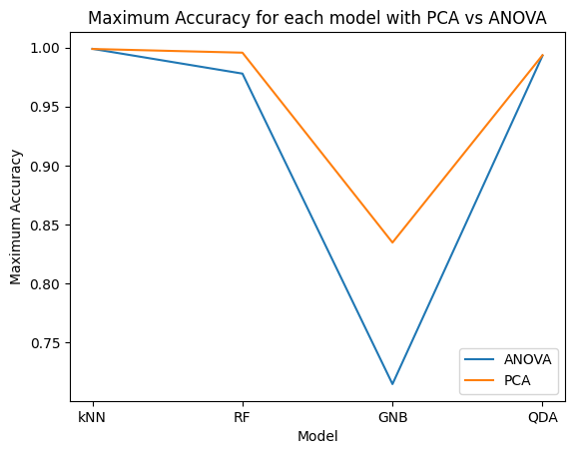

We measured the relative accuracies for all the models and even plotted the number of features vs. accuracy for all four algorithms namely kNN, Random Forest, Gaussian Naive Bayes and Quadratic Discriminant Analysis.

**Inferences:**

* Random forest algorithm is the slowest but a highly accurate model. When using PCA or ANOVA, the accuracy is close to 99% for more than 5 features.
* kNN is as accurate as Random Forest but a faster algorithm. Similar trend is seen in the plot for accuracy vs \#features for kNN as in RF.
* Quadratic Discriminant Analysis performs better with PCA than with ANOVA and is comparatively more accurate than Gaussian Naive Bayes.
* Gaussian Naive Bayes has the least accuracy of the four models implemented.

